Write a query to create a patients table with the date, patient ID, patient name, age, weight, gender, location, phone number, disease, doctor name, and doctor ID fields
CREATE TABLE patients (
"date" TEXT,
pid TEXT PRIMARY KEY,
p_name TEXT,
age INTEGER,
weight REAL,
gender TEXT,
location TEXT,
phone_no TEXT,
disease TEXT,
doctor_name TEXT,
doctor_id INTEGER
);

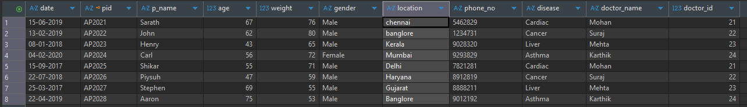

Display the total number of patients in the table.
Write a query to display the total number of patients in the table
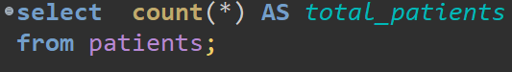


Write a query to display the patient id and patient name with the current date
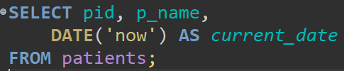
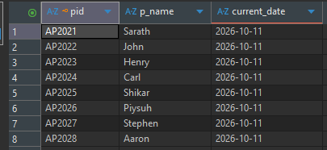

Write a query to display the old patient name and the new patient name in uppercase
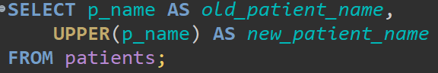
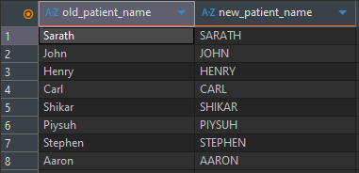

Write a query to display the patients' names along with the total number of characters in their name
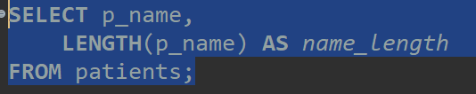
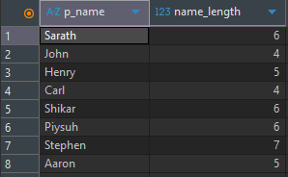

Write a query to combine the patient's name and the doctor's name in a new column
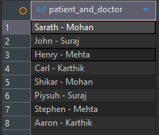

Write a query to extract the year for a given date and place it in a separate column
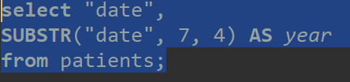
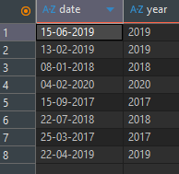

Write a query to display duplicate entries in the doctor name column
